Barcelona, Spain. Fira Gran Via Barcelona
Av. Joan Carles I, 64 ­ 08908 L'Hospitalet de Llobregat
IFBB ATHLETES

INFORMATION

THURSDAY 22nd SEPTEMBER

REGISTRATION 10:00 am till 8:00 pm
Registration and weight in will take place at the Fira of Barcelona next hall number 2. Address: Carrer Botanica, 08038 Barcelona, east access.(see picture below).
Time is between 10am and 8pm
At the entrance (area 1) there will be WAIVERS OF LIABILITY handed out. Fill one in and sign it. Take a number with your waiver of liability
You will pass to the IFBB Registration counter (area 2), where you will have to show the following: 1) IFBB International Card (Blue Book). If you don’t have an IFBB Blue Book, you can purchase one at registration counter for 30€. (This is an annual fee). 2) the PayPal receipt of your ACE Registration fee. If you haven't made it in advance by PayPal, you can made it directly (registration payments made at the registration day will be 200€)
With the WAIVER OF LIABILITY form, follow the signs to the Weigh­in/Measure (area 3) for your category.
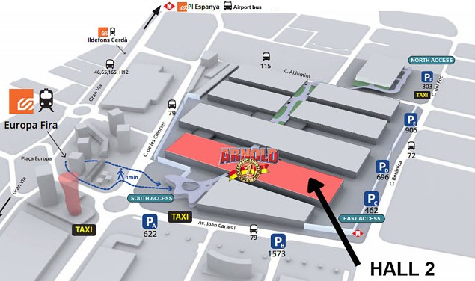Once your height and/or weight has been added to the Waver of Liability by the IFBB Official, take it to the final area, stadistics and list (area 4) where your name will be added to the athletes list in the right category.

2
1

22­25 Sept Friday to Sunday EXPO & COMPETITION ENTRANCE
(South access)
Thursday, Sept 22nd Registration and weight in
(East access)

REGISTRATION AND WEIGHT IN FLOOR MAP
C/ Botanica, 08038 Barcelona, (east access)

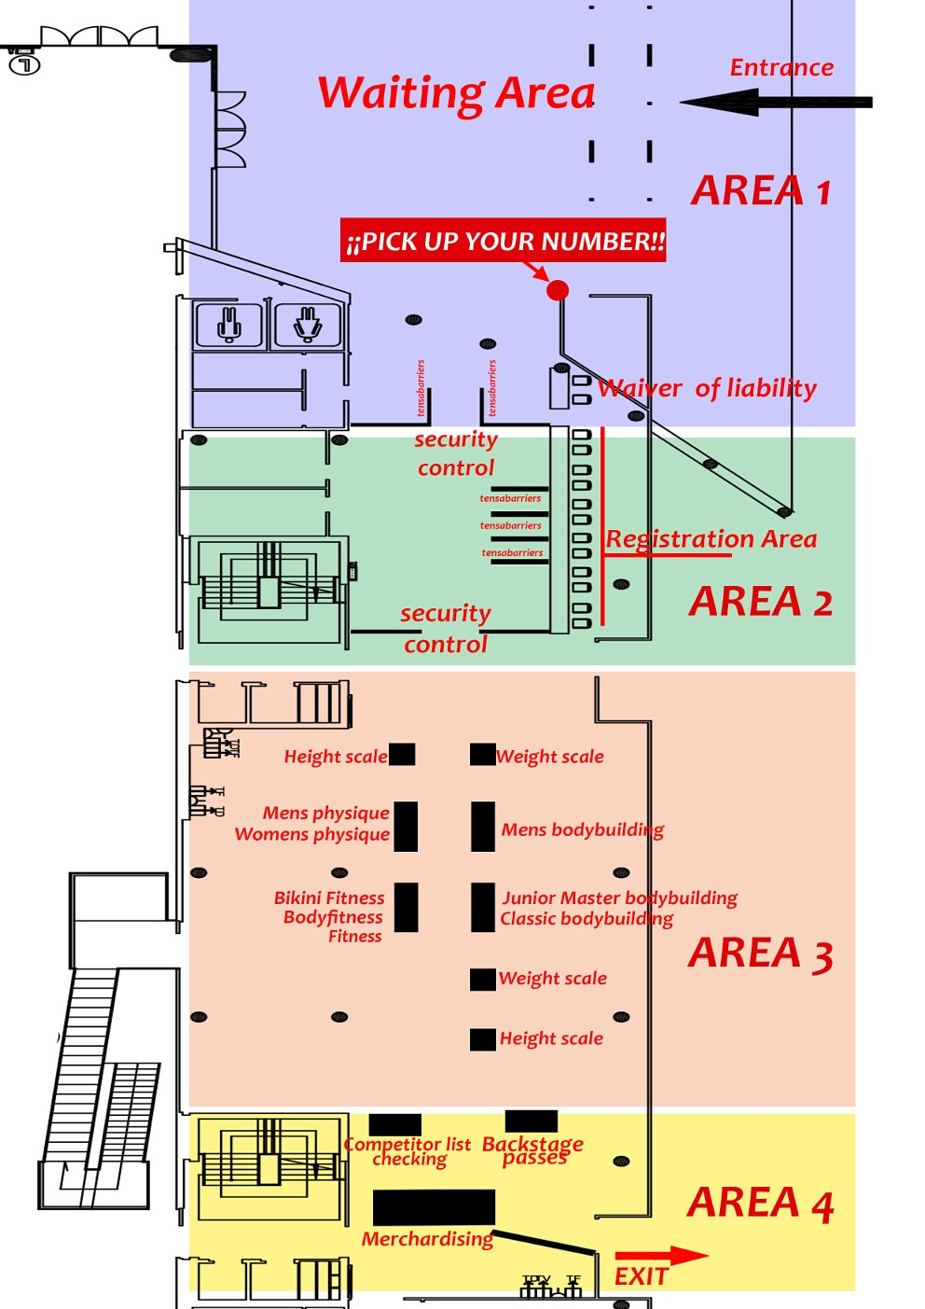

TANNING
Jan Tana will be present at the resgistration area locate at Carrer Botanica, 08038 Barcelona, (east access) on thursday from 8.00 am ­ 10.00 pm. On Friday, Saturday and Sunday from
7.00 am ­ 10.00 am Jan Tana will be at the backstage of the PRO SHOW stage (same access for registration) and from 10.00 am to 8.00 pm will be at the backstage of the Amateur stage in the EXPO.
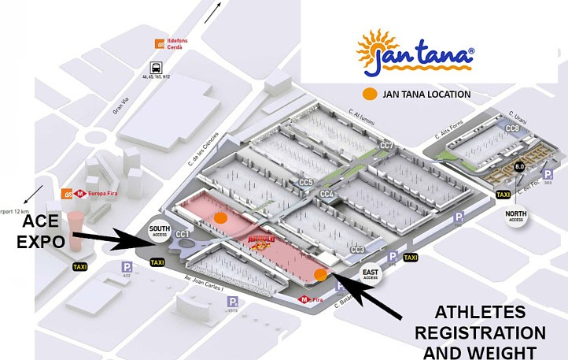
For those of you with tanning or makeup needs, contact Jan Tana at http://jantana.com/ or follow this link http://jantana.com/index.php/on­site­services/arnold­classic­europe­sep­23­25­ 2016.html to book an appointment to have your tan done before your competition. They also will have staff backstage to assist you with all competition needs

FRIDAY 23rd, SATURDAY 24th and SUNDAY 25th SEPTEMBER

ATHLETES ENTRANCE TO COMPETITION AREA
Please note that the access for the athletes will be exclusively by the SOUTH ACCESS (Av. Joan Carles I, 64, 08908 L'Hospitalet de Llobregat, Barcelona) identified as ATHLETE ENTRANCE.

COMPETITORS INFORMATION

Athletes participating in these Championships will be given a goodie bag and the wristband at the Official Athlete Registration run on Thursday, September 22nd, 2016. This wristband has to be worn during your whole stay and will allow you in and out of the Arnold Fitness EXPO and should not be removed. There is a special athlete seating area close to the stage and backstage.

BACKSTAGE ACCESS

Access to the backstage and/or dressing room areas shall be strictly limited to essential personnel only. Only official Delegates/Trainers possessing the Backstage Pass will be allowed to enter the backstage area. These passes will be distributed at the Team Managers and Judges Meeting, hold on Thursday, September 22nd, 2016, according to the following criteria: Less than five (5) competitors in a National Team ­ one (1) Backstage Pass
From five (5) to ten (10) competitors ­ two (2) Backstage Passes More than ten (10) competitors ­ three (3) Backstage Passes

PLEASE NOTE: There will be a limited number of extra Backstage Passes available at the Official Athlete Registration which can be purchased for EUR €50 each. This pass will allow the holder to go in and out of the venue during the weekend and will give access backstage and the athlete allocated seating area. This pass (wristband) has to be worn during your whole stay.

